Problem 3.1
Evaluation the residual equation for node one using the weighting function shown in Figure 3.1. Note that the answer is the same as Equation 3.1 with (e+1) = (1), s = 1, and t = 2.
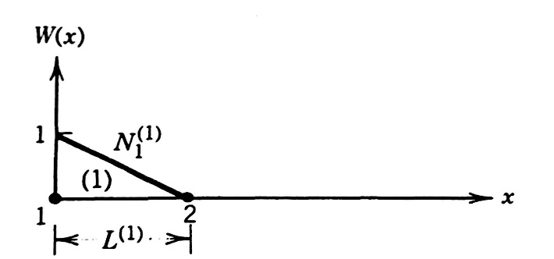
Figure 3.1
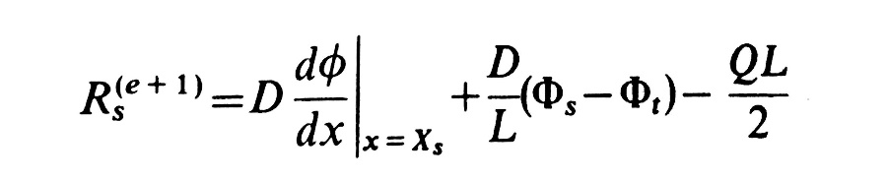
Equation 3.1

Problem 3.2
The residual equation for a uniform grid and a linear variation of Q(x) between nodes is given by
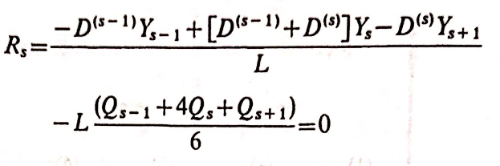
Use this equation to obtain the nodal displacements for the beam shown in Figure 3.2. The governing differential equation is
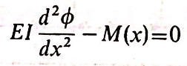
And M(x) is given in the Figure 3.2. Each element is 200 cm long; EI = 2(10¹⁰)N*cm².
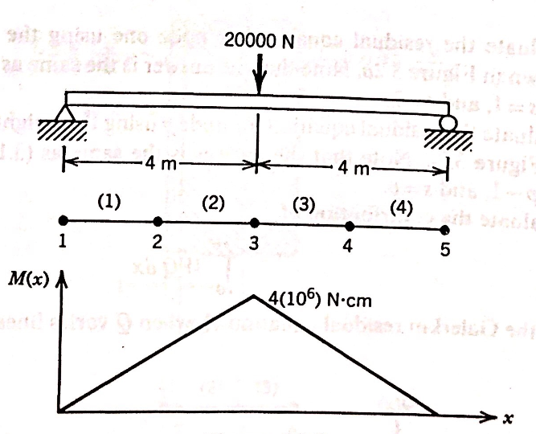
Figure 3. 2

Problem 3.3
Use the residual equation in Problem 3.2 to obtain the nodal displacements for the beam shown in Figure 3.3. The governing differential equation is
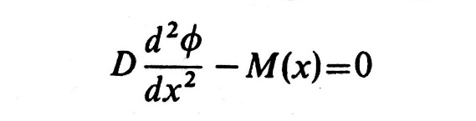
And M(x) is given in the figure 3.3. Each element is 300 cm long; EI = 2(10¹⁰)N*cm².
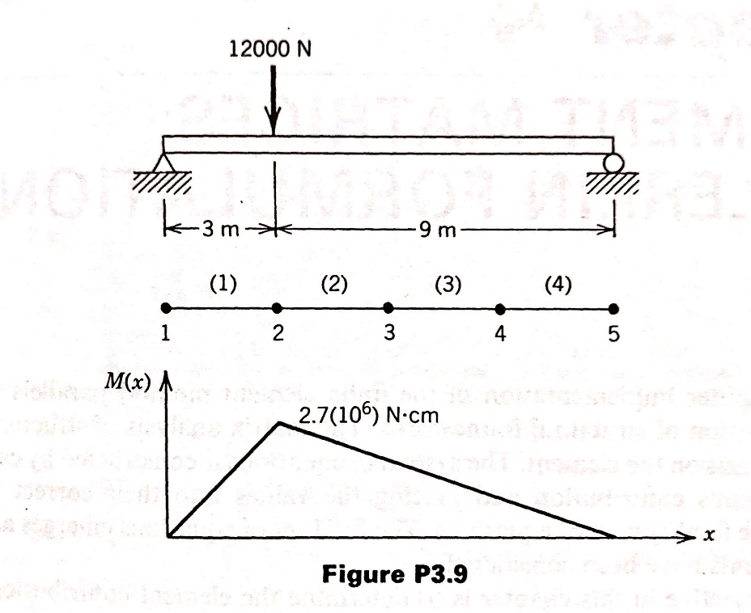
Figure 3.3
Problem 4.1
Develop the system of equations for the following problem using the element matrix and direct stiffness concepts discussed in Chapter 4. Modify the system of equations to incorporate the boundary conditions and solve for the unknown nodal values.
The differential equation D^{(e)}d²Φ/dx² = 0 is applicable to each section of the composite wall shown in Figure 4.1, where D^{(e)} is the thermal conductivity. Calculate the nodal temperature values within the wall and evaluate the heat flow through each material. The heat flow is given by q = -D^{(e)}dΦ/dx. A unit of surface area is assumed.
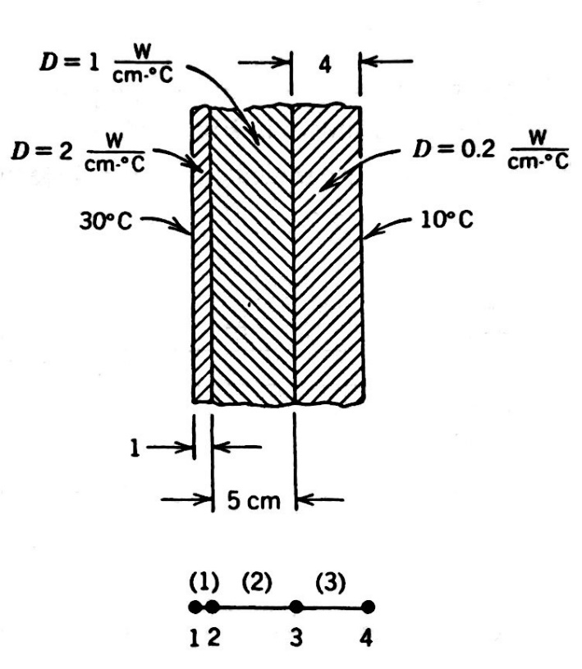
Figure 4.1

Problem 5.1
Verify that the shape functions for the triangular element sum to one, that is, N_{i} + N_{j} + N_{k} = 1. Comment on the behavior of the following summations:
- a_{i} + a_{j} + a_{k}.
- b_{i} + b_{j} + b_{k}.
- c_{i} + c_{j} + c_{k}.

Problem 5.2
The nodal values for the triangular elements are summarized below. This column of values is associated with an element and a specific problem.
- Calculate the value of Φ at the coordinates of point A.
- Determine the xy coordinates where the specified contour line intersects the element boundaries.
- Evaluate ∂Φ/∂x and ∂Φ/∂y within the element.
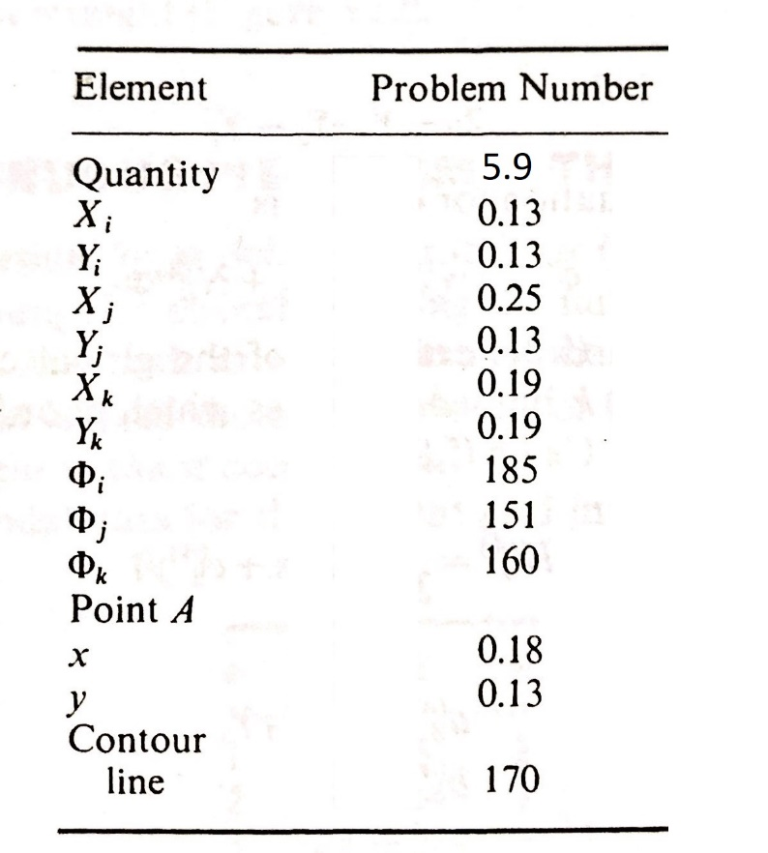

Problem 5.3
The nodal values for the rectangular elements are summarized below. This column of values is associated with an element and a specific problem.
- Calculate the value of Φ at the coordinates of point B.
- Determine three sets of xy coordinates for the specified contour line.
- Evaluate ∂Φ/∂x and ∂Φ/∂y at point B.
